## Home Page:

Top Nav:

* Can we Change “Learn about Sponsoring” button to redirect to the pdf autoloading on a new page? –OR- need to change the button to say: “Download Sponsorship Information” or something along those lines (think we need to be clear that if you press this button you are going to get a download of a document)
* I don’t think that “Influence” should stand alone (top left corner) but should say “Conference” below it as part of the image?

Image Banner:

* Change out Image background (currently hands typing on keyboard) to a branded Image from Images Shaun chose –> people at a conference
* Make “Marriott World Center” bigger text (currently hard to read as small as it is)
* “Where” “When” “Countdown” text bigger please (also are the section title suppose to be a diff. font than rest of pages?)

About Influence section:

* Title: Think need to change it to “About Influcence Conference”
* April writing copy for body text. We can size the image to line up with the amount of copy, correct? That way we don’t have a bunch of empty white space below the text as it currently is?

Agenda section:

* Can you make the section title bigger for “Agenda”?
* Under “Agenda” section the floating nav. Still has all options showing where the top Nav. Has all but About, Agenda & Travel hidden.
* Section Needs some love. Can we show the short breakdown of the overall conference here? Right now the image displayed & it just showing Wed. night looks strange to me. Curious what our options are.
  + Best option IMO - the high level overview is loaded here for both days (see below) & it hyperlinks to the full agenda page that has the full breakdown of the agenda for all days.
  + Wednesday Sept. 27th:
    - 6:00 pm Registration
    - 7:00 pm Opening Night Headline Event
  + Thursday Sept. 28th
    - 7:00 am Breakfast
    - 8:00 am Opening Sessions & User Group
    - 12:00 pm Lunch
    - 1:00 pm Sessions
    - 5:00 pm Cocktail Reception
    - 6:30 pm Dinner

Footer:

* Please make text bigger: for “Share”, “powered by” and “Influence Health is the leaders in consumer healthcare experience. Learn more.” – Also can you have the hyperlink open in a new page so that it does not redirect from the conf. page?

## About Page:

* Really like how inbound lays out their about section. See below. Do you think we could do something like this. Helps break up the text & makes it clear to why you should join us?
* I can edit the text associated but would like a more visually appealing breakout of the about section, if possible.

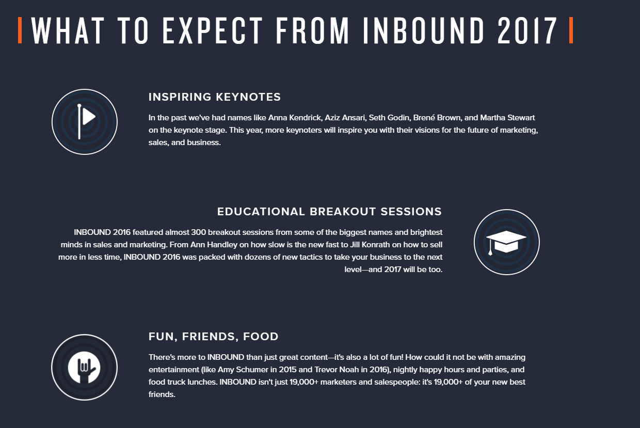

## Agenda Page

* April working on text for beginning of the page to precede the actual agenda. Will have to you on Tuesday.
* Would like the full agenda to load on this page, not just per day. Possible?

## Travel

* April working on messaging for the page. Think we could also include a cool image of the hotel here along with the map.
* Can we put more space between the “Find Flights” and “Reserve a Room” buttons? They seem to be close to each other & the map.